**Final Project – Design Document**

**PHP (PROG1191)**

By: Alexander, Dylan, Eldar, John, Neil

Date: Nov 26, 2020

**Table of Contents**

|  |  |
| --- | --- |
|  | **Mockups/Wireframes:**  Guest - View Team Statistics  Guest - View Tournament Standings  Scorekeeper - View List of Scheduled Games and Statuses  Scorekeeper - Scoring  Admin - Create a Player  Admin – Teams Menu |
|  | **Use Case Diagrams:**  Use Case Diagram |
|  | **Use Case Narratives:**  GST-1: View Teams/Players  GST-2: View Team Statistics  SCK-1: View Scheduled Games and Statuses  SCK: Score a Game  SYS-1: Generate Rankings for a Round  ADM-1: Create a Team |

**Wireframe**

# Guest – View Team Statistics

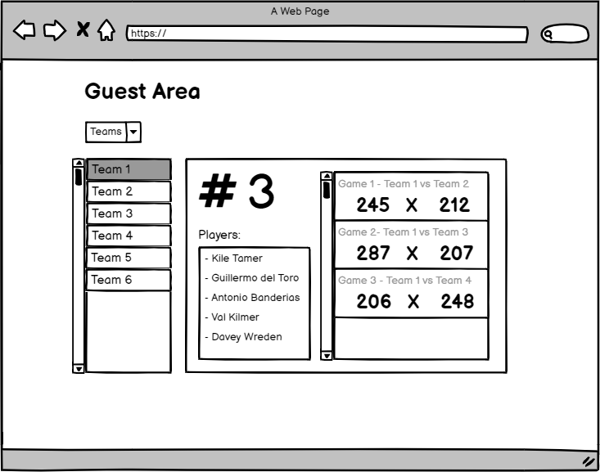

**Wireframe**

# Guest – View Tournament Standings

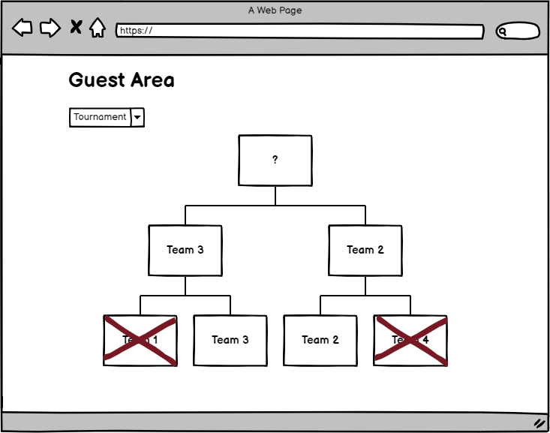

**Wireframe**

# Scorekeeper – View List of Scheduled Games and Statuses

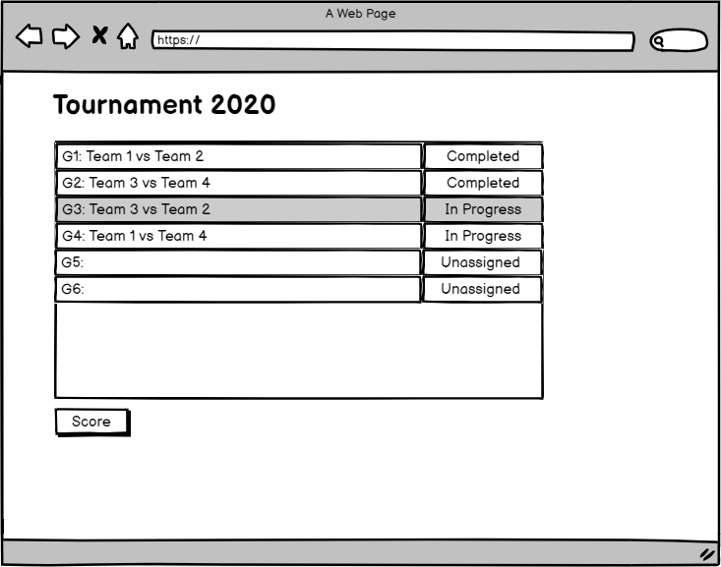

**Wireframe**

# Scorekeeper - Scoring

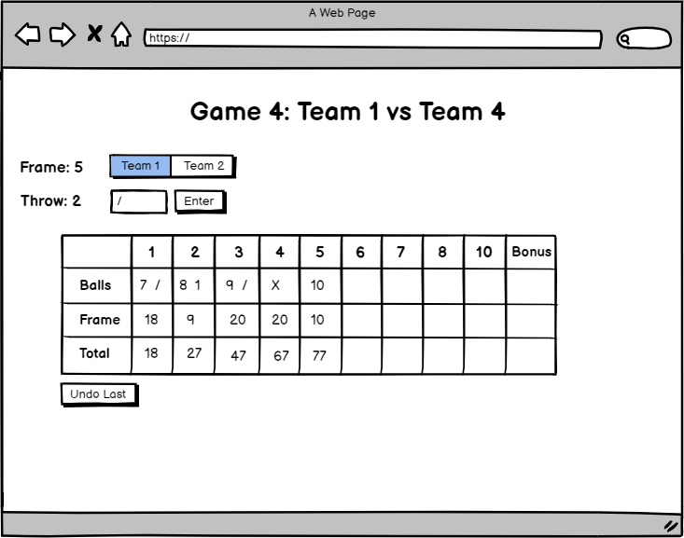

# Wireframe Admin – Create a Player

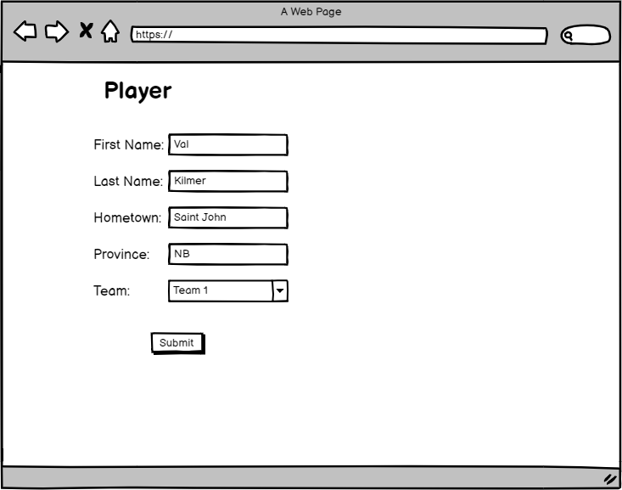

**Wireframe**

# Admin – Teams Menu

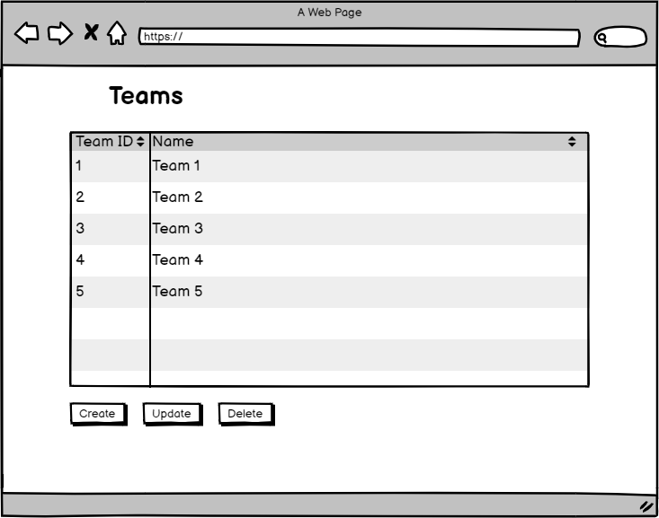

**Use Case Diagram**

# _

**Use Case Narratives**

# GST-1: View Teams/Players

**Use Case Narratives**

# GST-2: View Team Statistics

**Use Case Narratives**

# SCK-1: View Scheduled Games and Statuses

**Use Case Narratives**

# SCK-2: Score a Game

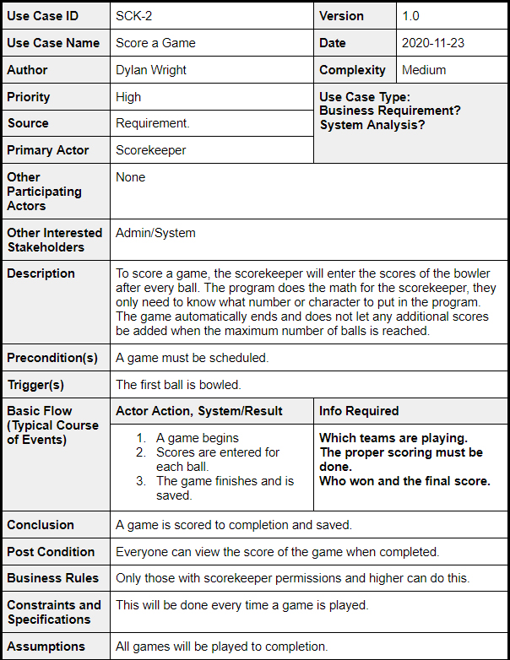

**Use Case Narratives**

# SYS-1: Generate Rankings for a Round

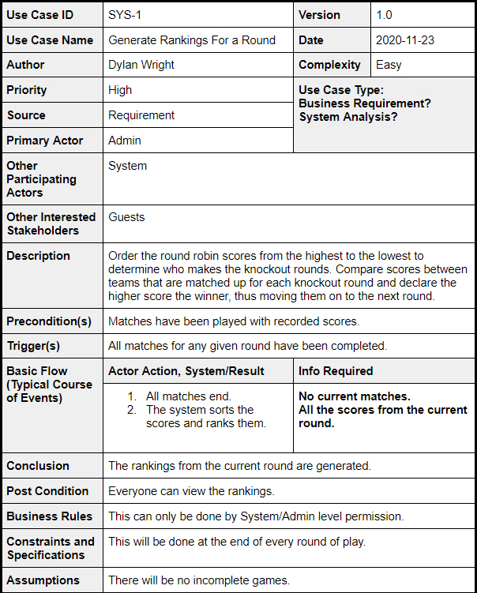

**Use Case Narratives**

# ADM-1: Create Team